Mechanism by Long

1. **Introduction**

The family of steering equipment covers hydrostatic steering systems, recirculating ball-with-nut gears, manual rack-and-pinion steering and rack power steering. The final steering system mentioned has a rack-and-pinion gear which transforms the rotation of the steering wheel into the translation of the rack and again into the steering movement of the tyres.

1. **Hệ thống cơ khí và động lực học hệ thống lái EPS (Mechanics and steering dynamics in EPS system)**
2. **Vô lăng (Steering wheel)**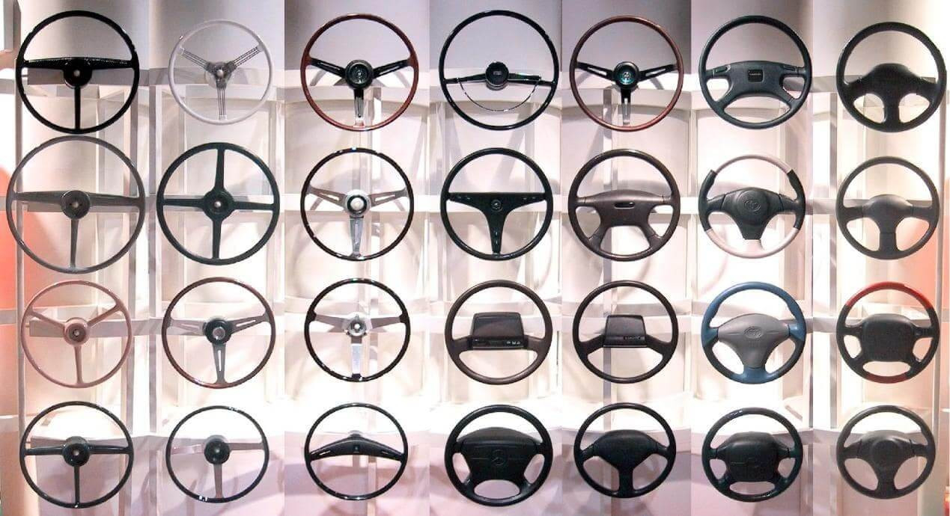

Function: Obviously, a steering wheel and the system it connects to primarily controls the direction of a vehicle. It converts rotational commands of the driver into turning movements of the vehicle’s front wheels.

**Steering Ratio (source: steering handbook)**

Once the greatest necessary steering wheel angle is known, the required gear ratio between steering wheel and front tyres must be defined. Regulations for road vehicles stipulate (so far) a permanent mechanical connection between steering wheel and steered tyres. The steering movement is transferred from the wheel to the tyres by the steering linkage (tie rods, drag links etc.), operated by a steering gear (Fig. 4.13). The gear has an internal gear ratio iG to reduce the steering wheel forces. The linkage usually has a gear ratio between gear and tyres that is changing with the steering wheel angle.

The kinematic steering ratio iS from wheel to tyres results from the wheel angle δH and the steering wheel angles:

iS = δH / δm

iS kinematic steering ratio

δH steering wheel angle (in degree)

δm mean steering wheel angle of the tyres (in degree). δm = (δo + δi)/2.

Fig.

1. **Cơ cấu lái bánh răng – thanh răng (Rack and pinion)**

Rack-and-pinion steering has replaced the recirculating ball gear in almost any vehicle with independent suspensions of the front axle, because of the lower steering elasticity, less need for space, less weight of the full steering system  
and lower production costs. the lateral forces from the tie rods—are compensated by constructive measures.

**\* Design and Main Components of a Mechanical Rack-and-Pinion Gear**Some essential components of a mechanical rack-and-pinion gear that are  
important for the steering are shown in Figs. 11.4 and 11.5:

1: gear case  
2: pinion  
3: rack  
4: rack yoke elements, including spring and adjuster bolt of the free travel  
5: rack bushing  
6: upper and lower roller bearings of the pinion  
7: upper pinion screw to secure the axial mounting of the pinion  
8: joining elements to receive and mount the gear case on-board  
9: gear case gasket towards vehicle interior, near the junction of the pinion to the  
column (use depends on the on-board implementation of the gear)  
10: tie rods (inside and outside joint)  
11: gaiters including coupling clamps.

**4. Tỉ số truyền hệ thống lái, cơ cấu lái, dẫn động lái (Gear ratio steering system, steering mechanism, steering drive)**

**11.3.5 Kind of Gear Ratio**

The stroke of the rack during one turn of the pinion is called the gear ratio of a rack-and-pinion gear. This means that for a higher gear ratio (more stroke per turn of the pinion), the whole steering ratio on-board will drop (wheel-angleto-steer-angle ratio). A high gear ratio means that there is less effort for a wheel angle, for example on curvy roads or when cornering in the city. On the other hand, a high gear ratio complicates the exact adjusting of very small steer-angles, for example, when slight corrections of the straight course should be carried out at high speed. Moreover, a high gear ratio produces high steering forces in a manual steering and high power-assist torques in electromechanical steering systems.

**Dovetailing and Gear Ratio**

The purpose of the dovetailing design is to include different limiting criteria, like high load-carrying capacity, high efficiency, low noise and high bending strength of the rack. Some of the individual measures generate opposing effects, demanding a compromise. For any given rack diameter, one tries to achieve the highest possible overlapping of profile and jump. The remaining cross section may not be weakened too much, otherwise the bending strength of the rack will be impaired. Constant and variable gear ratio are distinguished.

**11.5.1 Constant Gear Ratio**

The use of gears with constant gear ratio (CGR) is widespread in the car industry, where customary steering is concerned. The historical reason is the easier production by broaching. Broaching is acknowledged as an established manufacturing method for ‘common’ rack dovetailing, and it is most often applied; sanding and milling the dovetailing belong to the less widespread processes. The full ratio of a consistently translated gear is computed from the centre gear ratio and the steering axis geometry of the vehicle. Consequently, the choice of a suitable gear ratio is a compromise between the preferred ratio in the centre area (or ‘straight ahead’ position), the desired manoeuvrability of the vehicle and the full number of steering wheel rotations, stop unit to stop unit. The possibility to individually adapt the steering qualities by a variable gear ratio is a comfortable solution to find the best compromise for layout and adaptation of a steering system. With regard to rules for the dovetailing design, the CGR is a special case of the variable gear ratio, so that the layout criteria discussed in the following sections also apply to CGR dovetailing.

**11.5.2 Variable Gear Ratio**

The above-mentioned manufacturing methods are not applicable for variable dovetailing with a flank geometry changing over the stroke. Hence, racks with variable dovetailing in mass production are either hot or cold transformed. Dovetailing with variable gear ratio (VGR) uses a helical pinion, just like the CGR versions. The flanks of the rack cogs are bent, so that the same angles of the engaging cogs are present at any time of engagement. The left side of Fig. 11.14 shows the front cut through rack and pinion dovetailing. In the distance of the pitch circle diameter d1, the cogs of the rack have a frontal division pt1 (normal division to the pinion axis) and a related engagement angle. If the engagement angle rises, the contact lines are shifted towards the head of the respective pinion cog. The right side of Fig. 11.14 shows a rise of the engagement angle in the front cut. Accordingly, the contact lines between pinion and rack cogs are separated by the pitch circle diameter near the cog heads of the pinion. The chamfer angle βz2 of the rack dovetailing turns into d2 when the pitch circle diameter is large, because the chamfer angle of the pinion cogs rises with the diameter.

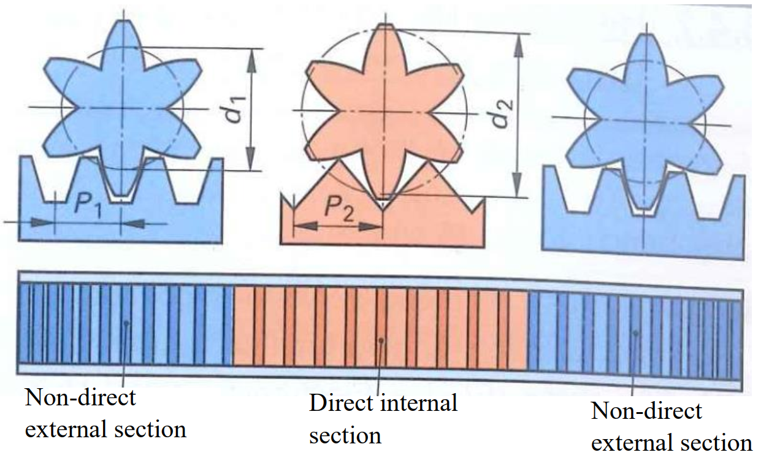

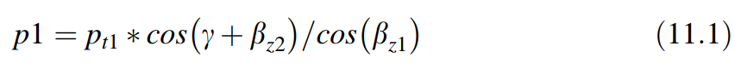Figure 11.15 shows the different chamfer angles of the pinion for different pitch circle diameters. Under the influence of a small engagement angle and assuming an ‘installation angle’ γ of the gear, the axial division p of the rack cogs is:

The gear rack travel Sy per steering wheel rotation (‘slope’ or ‘C factor’) is, using the number of the pinion cogs n:

As a result of the variation of the engagement angle (in the normal cut) of the  
rack cogs, the chamfer angle βz and the module m are non-constant (cf.  
Fig. 11.15).

Fig. 11.15 Different chamfer angles with different pitch circle diameters of the pinion



III. Reduction gear box

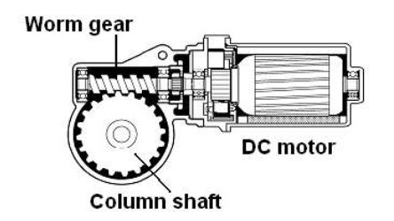

Function:

* Transmit the torque from the motor to the steering axis
* Amplify rotary torque of electric motor
* Transmiting Ratio

u = $\frac{n_{1}}{n_{2}}$ = $\frac{Z_{2}}{Z_{1}}$

Note:

* $n_{1}$, $n_{2}$: the angular speed of worm shaft and worm gear respectively
* $Z_{1}: The number of thread$ of worm shaft
* $Z_{2}$: the number of teeth of worm gear

ECU and Control by Minh

I/ ECU

ECUs for EPS basically include signal-processing electronics, to compute the  
currently required power assist, and power electronics, to feed the electric motor  
accordingly

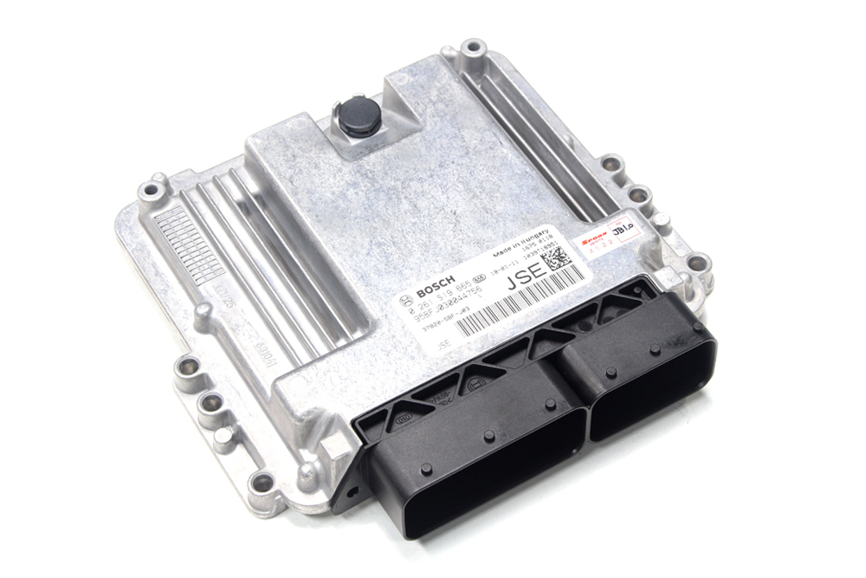

Fig.

ECUs are preferably arranged close to the EPS motor, to keep electric loss as low as possible.

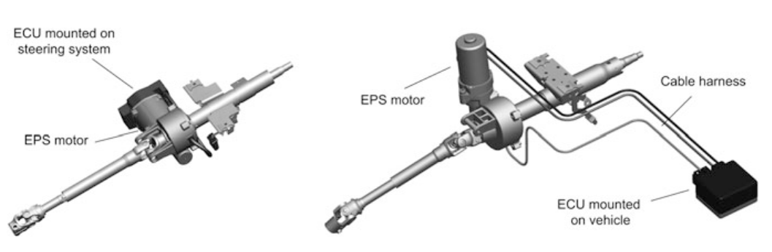

The compact vehicle segment's EPSColumn systems are also able to place a standalone ECU because of its low energy needs and limited space for installation. They are not arranged at the drive shaft, but are connected to the electric motor by lines of 1 m length. The drawbacks of this type are electrical energy distribution losses and complicated wiring. Therefore, many models have integrated the ECU with the motor to increase control efficiency, receive signals and reduce costs.

Recent EPS-ECUs communicate with other vehicle control systems, like the Electronic Stability Programme (ESP) or the vehicle diagnostics, by bus systems. The CAN-bus, used in chassis applications most often with transmission rates of 500 kBit/s, is complemented with the Flexray bus, enabling transfer rates of up to 10 MBit/s

Requirements for EPS-ECU

• Power supply voltage: 9-12V

• Maximum power consumption: <250μA

• Operating temperature: -40 to 125 degrees Celsius

II/ Micro-controller

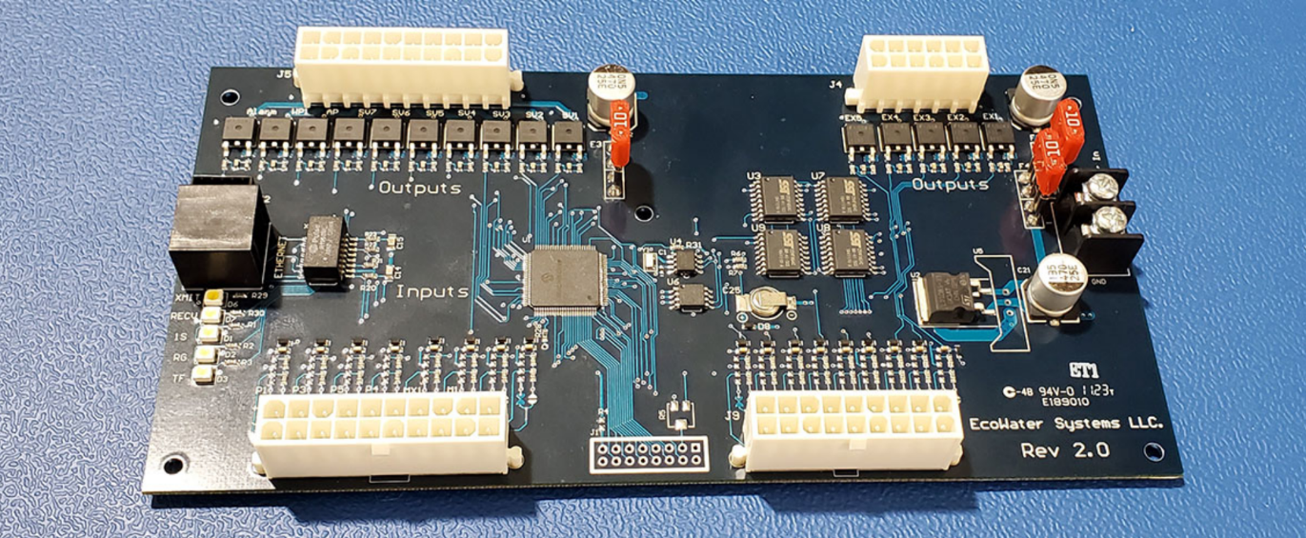

These microcontrollers are programmed in C language, including special programs such as

• Automotive applications

• Real-time operating system and providing communication and network management services

The microprocessor will convert the PWM signal (pulse width) into a voltage signal to control the Mosfets to supply power to the motor.

PWM (Pulse Width Modulation) method is a method of adjusting the output voltage of the load, or in other words, a modulation method based on the change of the width of the square pulse sequence, resulting in a change in the output voltage...

III/ Control

1. Torque control loop

We send the input signal (desired torque) to the controller and it will compare with the actual torque (measured torque) to find out the error. After that, controller will send the signal u to correct the output torque that optimize the error value. This process will repeat Diagram

1. EPS system control diagram
   * 1. H bridge

When mode switching signal indicates right , FET (a) is driven to ON , and at the same time, FET (c) is driven through PWM driving signal based on output data . When mode switching signal indicates left , FET (b) is driven to ON and at the same time, FET (d) is driven through PWM driving signal based on output data . When mode switching signal indicates the neutral, all FET from (a) to (b) become OFF .

* + 1. General diagram

Operation:

* Input signal from the vehicle speed sensor is measured and processed to obtain vehicle speed data
* Input signal that relating to torque and its direction from the torque sensor are measured and processed to obtain torque data and its direction data
* Input signal that relating to rotation speed from the rotation speed sensor are measured and processed to obtain rotation speed data
* After that, EPS MCU can calculate the final motor torque from above data tables and send a signal to power unit (motor) to rotate through the H bridge.
* In addition, trouble diagnosis for the sensors and the microprocessor is also carried out. When a problem is detected, power to the motor is interrupted, an indicator lamp illuminates, and the problem condition is memorized. Then this problem mode flashes on a display as necessary.